Work Blueprint Documentation

1-WorkLogs

Knowledge Base

✅ What is " WorkLogs" mean?
# Source: AI Source: Provided by: [Data Path: Persons Table -> ID Column: 1, Name_En Column: Motasem Essam] -> From: [ChatGPT] on [6/4/2025]
Stores the complete chronological history of all work-related events, changes, updates, schedules, periods, covenants, responsibilities, promotions, application methods, reasons for leaving, and other employment activities associated with the company record.

Rules and Guidelines

1-WorkPeriodLog
# Source: AI Source: Provided by: [Data Path: Persons Table -> ID Column: 1, Name_En Column: Motasem Essam] -> From: [ChatGPT] on [6/4/2025]
Description:

Stores all employment periods worked in the company (including rehires, gaps, corrections).
Format
- Index -> User Information -> Timestamp -> ActionType -> [PeriodStart=Value, PeriodEnd=Value]
Columns
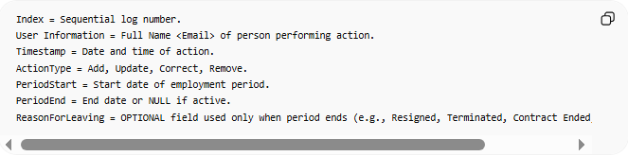
Index = Sequential log number.
User Information = Full Name <Email> of person performing action.
Timestamp = Date and time of action.
ActionType = Add, Update, Correct, Remove.
PeriodStart = Start date of employment period.
PeriodEnd = End date or NULL if active.
ReasonForLeaving = OPTIONAL field used only when period ends (e.g., Resigned, Terminated, Contract Ended, Career Change).
Example
- 1 -> User Information: Data Path: Persons Table -> ID Column: 6, Name_En Column: Ahmed Ali -> 2025-01-01 09:00:00 -> Add -> [PeriodStart=2020-01-01, PeriodEnd=2021-06-30]

2-JobTitleLog
# Source: AI Source: Provided by: [Data Path: Persons Table -> ID Column: 1, Name_En Column: Motasem Essam] -> From: [ChatGPT] on [6/4/2025]
Description:
Tracks job titles, promotions, demotions, transfers, and role updates.
Format
- Index -> User Information: Data Path: Persons Table -> ID Column: X, Name_En Column: Y -> Timestamp -> ActionType -> [Title=Value, From=Value, To=Value]
Columns
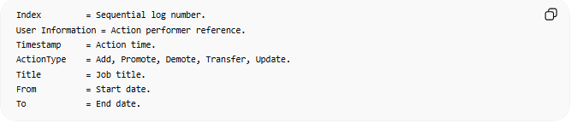
Index = Sequential log number.
User Information = Action performer reference.
Timestamp = Action time.
ActionType = Add, Promote, Demote, Transfer, Update.
Title = Job title.
From = Start date.
To = End date.
Example
- 1 -> User Information: Data Path: Persons Table -> ID Column: 8, Name_En Column: Sara Hassan -> 2025-01-01 09:15:00 -> Promote -> [Title=Senior Developer, From=2021-01-01, To=Present]

3-WorkingScheduleLog
# Source: AI Source: Provided by: [Data Path: Persons Table -> ID Column: 1, Name_En Column: Motasem Essam] -> From: [ChatGPT] on [6/4/2025]
Description:

Tracks working days, hours, shifts, calendars, and schedule changes.
Format
- Index -> User Information: Data Path: Persons Table -> ID Column: X, Name_En Column: Y -> Timestamp -> ActionType -> [Days=Value, Hours=Value, DailyHours=Value, Calendar=Value, From=Value, To=Value]
Columns
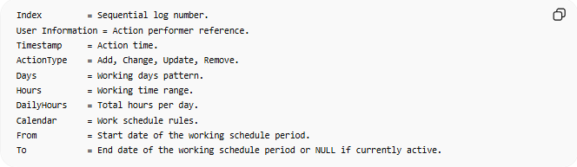
Index = Sequential log number.
User Information = Action performer reference.
Timestamp = Action time.
ActionType = Add, Change, Update, Remove.
Days = Working days pattern.
Hours = Working time range.
DailyHours = Total hours per day.
Calendar = Work schedule rules.
From = Start date of the working schedule period.
To = End date of the working schedule period or NULL if currently active.
Example
- 1 -> User Information: Data Path: Persons Table -> ID Column: 8, Name_En Column: Omar Khaled -> 2025-01-01 09:30:00 -> Change -> [Days=Sat–Thu, Hours=08:00-16:00, DailyHours=8, Calendar=Standard, From=2025-01-01, To=NULL]

4-CovenantLog
# Source: AI Source: Provided by: [Data Path: Persons Table -> ID Column: 1, Name_En Column: Motasem Essam] -> From: [ChatGPT] on [6/4/2025]
Description:
Tracks legal employment covenants including NDAs, non-compete agreements, confidentiality agreements, and material financial responsibility obligations.
Format:
- Index -> User Information: Data Path: Persons Table -> ID Column: X, Name_En Column: Y -> Timestamp -> ActionType -> [Type=Value, Status=Value, EffectiveFrom=Value, EffectiveTo=Value, FinancialResponsibility=Value, Details=Value]
Columns
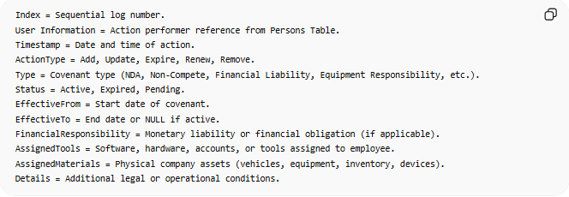
Index = Sequential log number.
User Information = Action performer reference from Persons Table.
Timestamp = Date and time of action.
ActionType = Add, Update, Expire, Renew, Remove.
Type = Covenant type (NDA, Non-Compete, Financial Liability, Equipment Responsibility, etc.).
Status = Active, Expired, Pending.
EffectiveFrom = Start date of covenant.
EffectiveTo = End date or NULL if active.
FinancialResponsibility = Monetary liability or financial obligation (if applicable).
AssignedTools = Software, hardware, accounts, or tools assigned to employee.
AssignedMaterials = Physical company assets (vehicles, equipment, inventory, devices).
Details = Additional legal or operational conditions.
Example
- 1 -> User Information: Data Path: Persons Table -> ID Column: 3, Name_En Column: HR Team -> 2025-01-01 10

5-SalaryLog
# Source: AI Source: Provided by: [Data Path: Persons Table -> ID Column: 1, Name_En Column: Motasem Essam] -> From: [ChatGPT] on [6/4/2025]
Description:
Tracks the complete financial compensation history of an employee within a company, including base salary, adjustments, bonuses, deductions, allowances, and payment status over time. This log ensures full transparency of salary evolution and supports auditing, payroll reconciliation, and financial reporting.

Format
- Index -> User Information -> Timestamp -> ActionType -> [BaseSalary=Value, Currency=Value, Bonus=Value, Deduction=Value, NetSalary=Value, EffectiveFrom=Value, EffectiveTo=Value, PaymentStatus=Value]

Columns
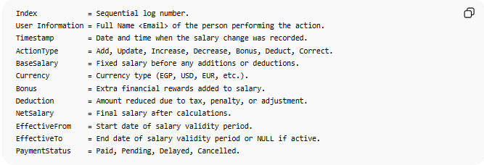
Index = Sequential log number.
User Information = Full Name <Email> of the person performing the action.
Timestamp = Date and time when the salary change was recorded.
ActionType = Add, Update, Increase, Decrease, Bonus, Deduct, Correct.
BaseSalary = Fixed salary before any additions or deductions.
Currency = Currency type (EGP, USD, EUR, etc.).
Bonus = Extra financial rewards added to salary.
Deduction = Amount reduced due to tax, penalty, or adjustment.
NetSalary = Final salary after calculations.
EffectiveFrom = Start date of salary validity period.
EffectiveTo = End date of salary validity period or NULL if active.
PaymentStatus = Paid, Pending, Delayed, Cancelled.

Example
- 1 -> User Information: Data Path: Persons Table -> ID Column: 6, Name_En Column: Ahmed Ali -> 2026-01-01 09:00:00 -> Update -> [BaseSalary=15000, Currency=EGP, Bonus=2000, Deduction=500, NetSalary=16500, EffectiveFrom=2026-01-01, EffectiveTo=NULL, PaymentStatus=Paid]

